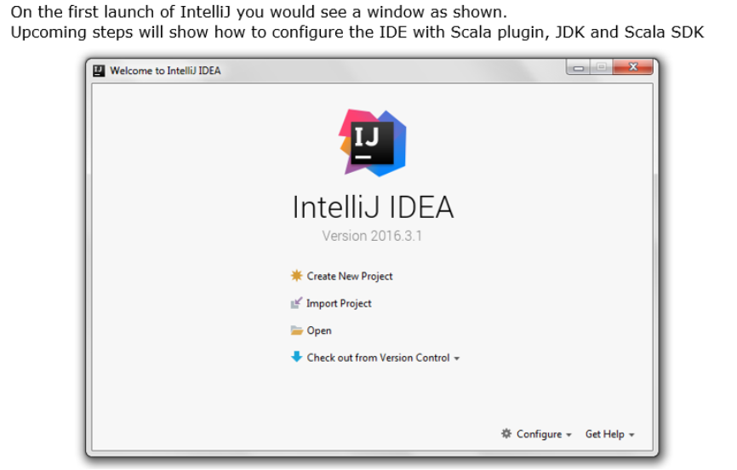

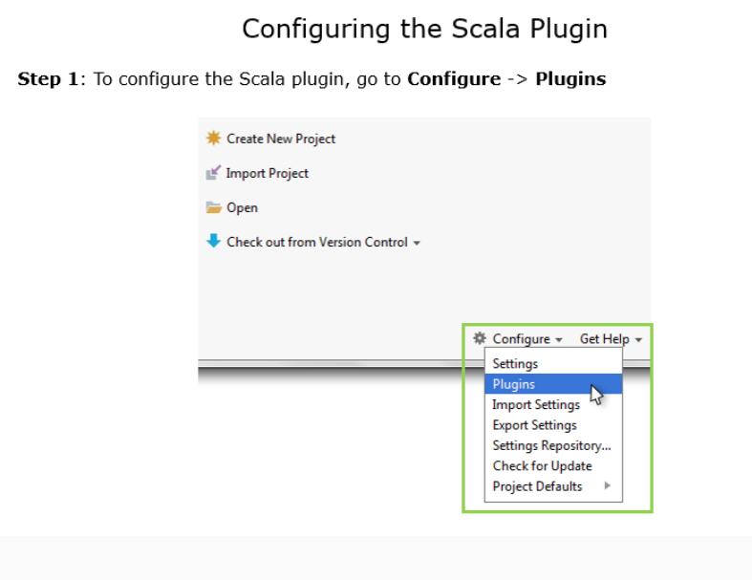

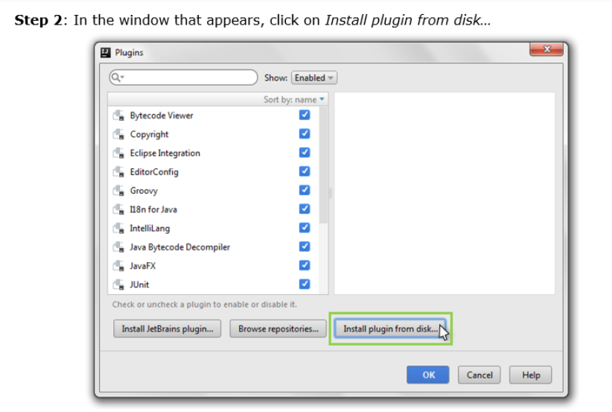

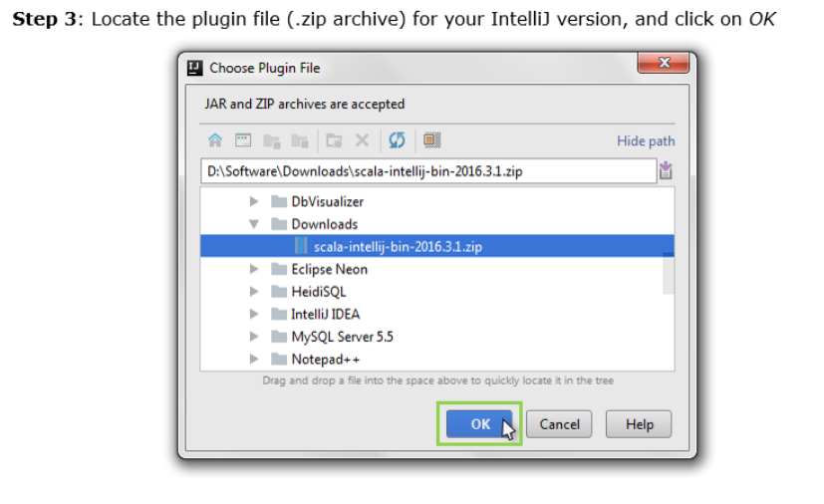

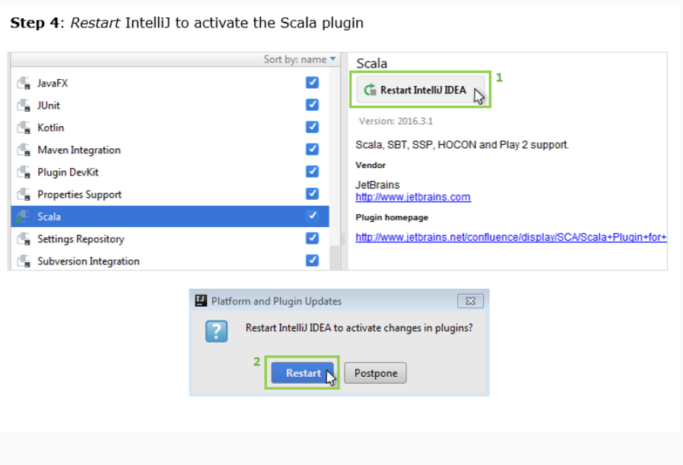

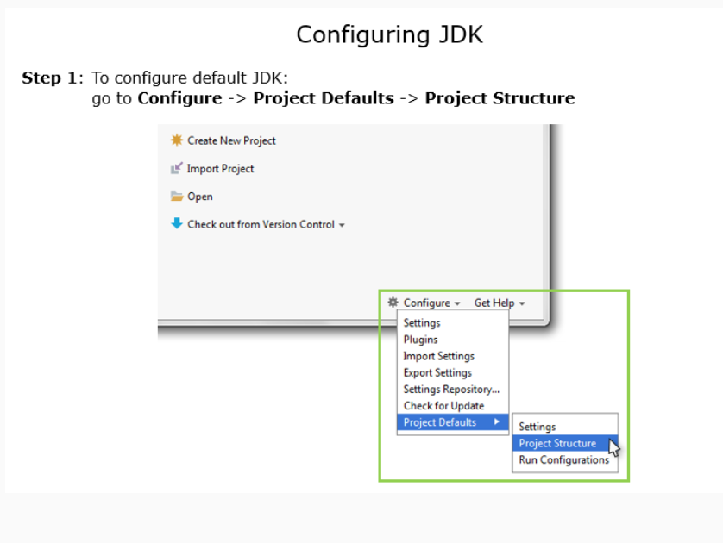

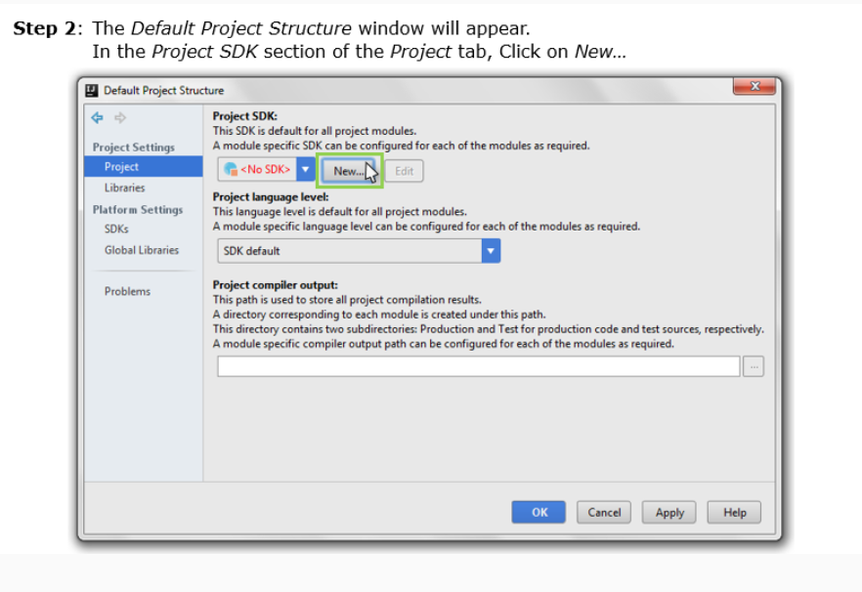

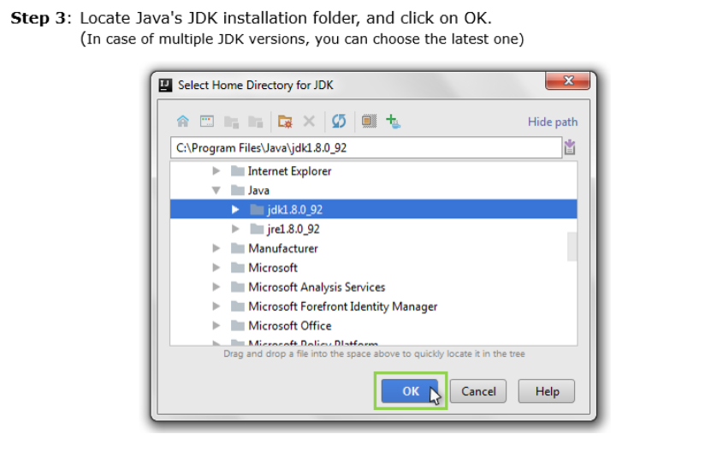

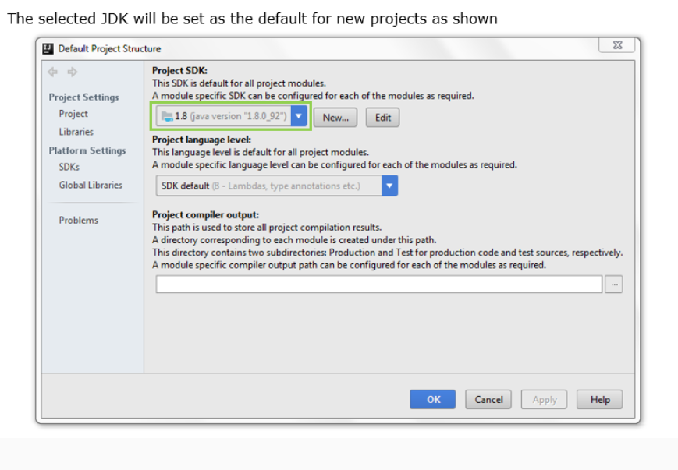

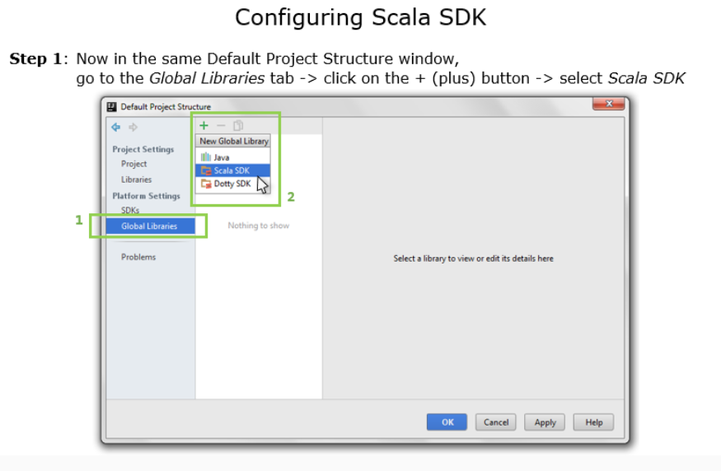

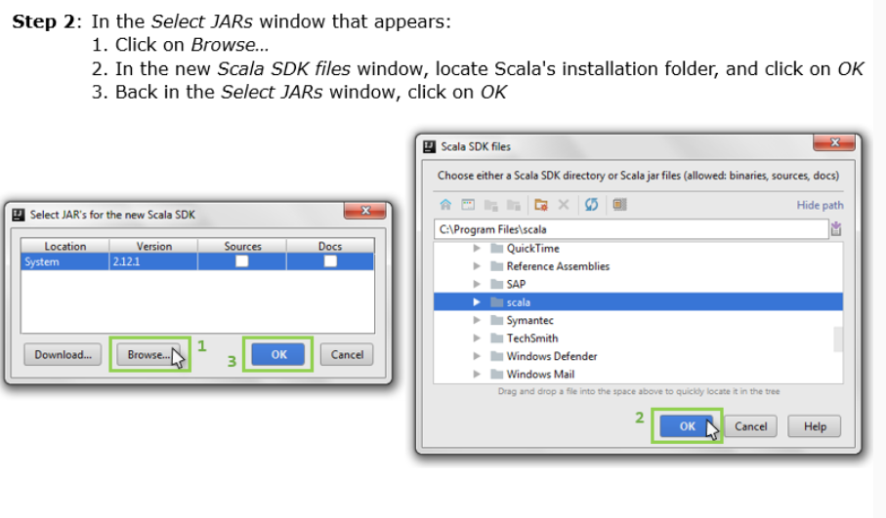

If files are not present it will download other wise search for

<https://www.scala-lang.org/download/2.12.2.html>

and download for windows and extract and click on scala >> lib >>and load all jar files

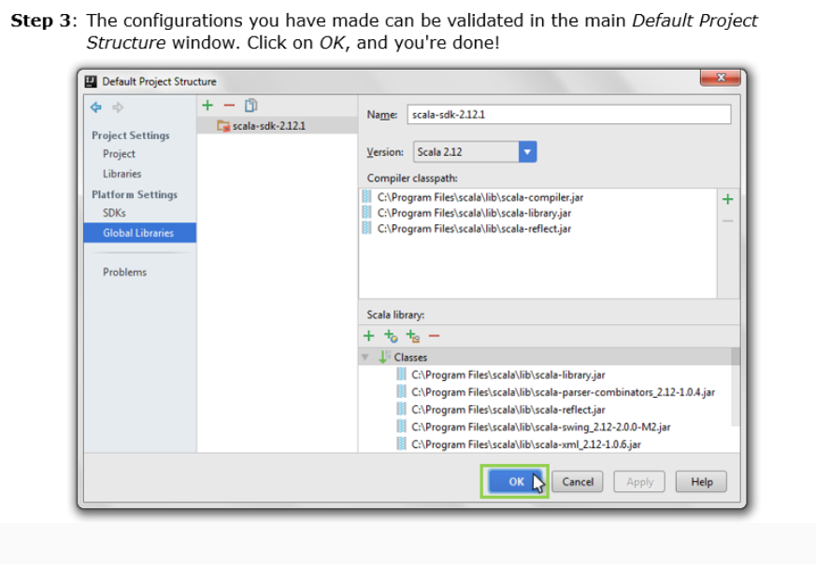­­­­

== Before starting need to set proxy for internet connection

1. Go to file >> settings >> search for proxy
2. Select manual proxy and place hostname and other
3. Proxy authentication enter credentials
4. Check connection

== After all the the jar files are installed start the scala project

1. Select file >> new >> project >> scala>> enter like below
2. Need to load the java version which is downloaded separately or existing in system

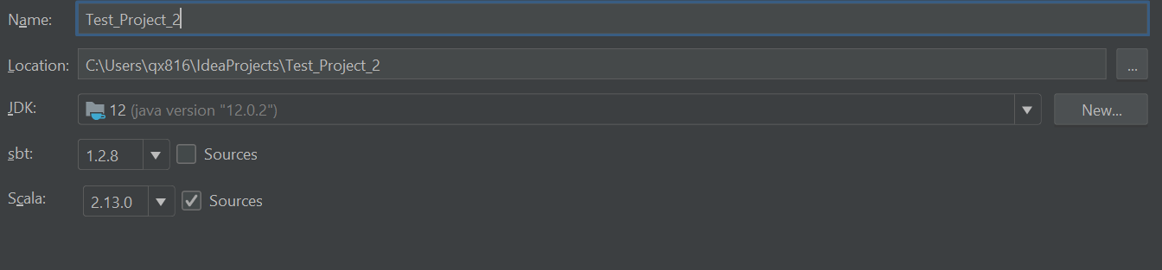

First Program(Without SBT)

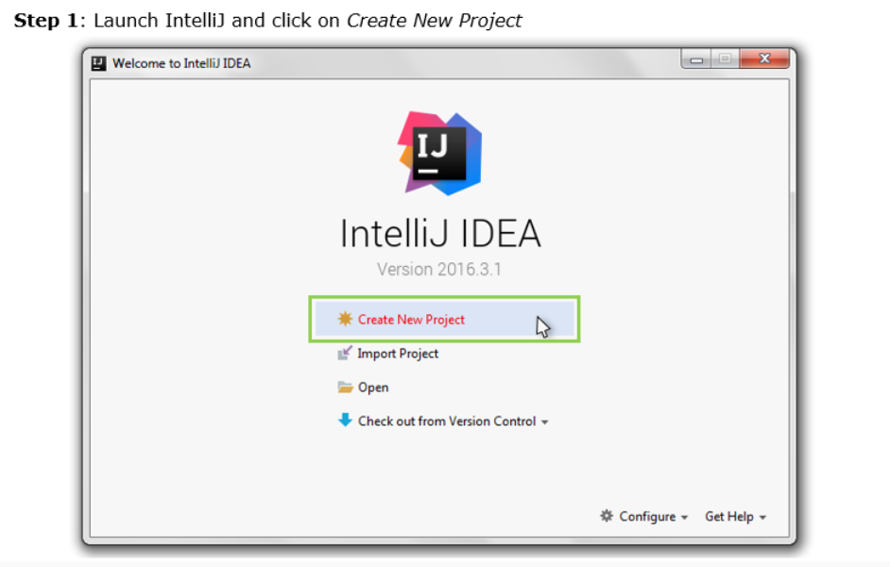

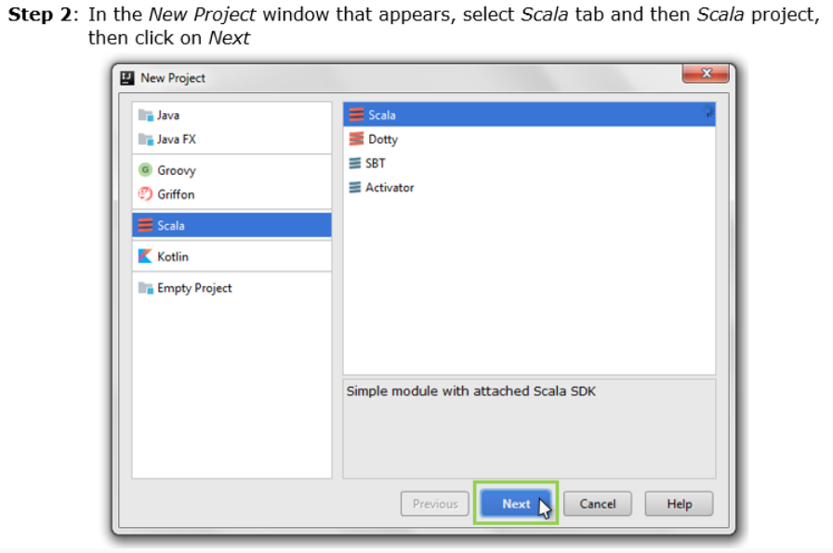

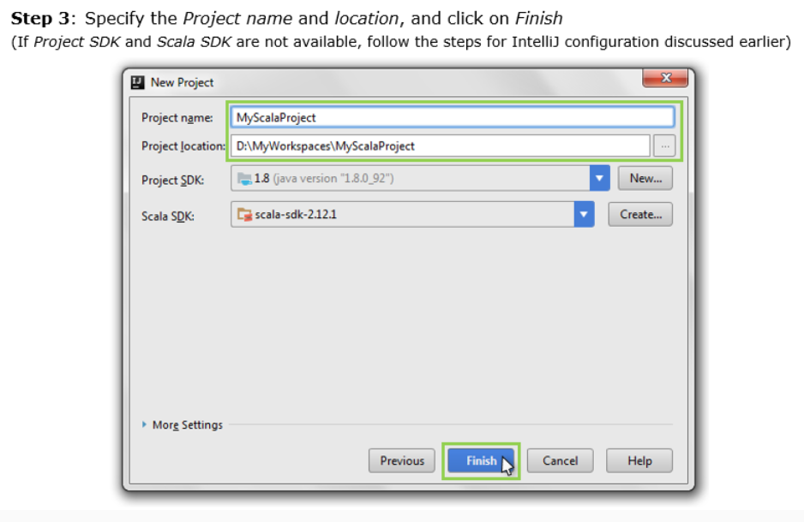

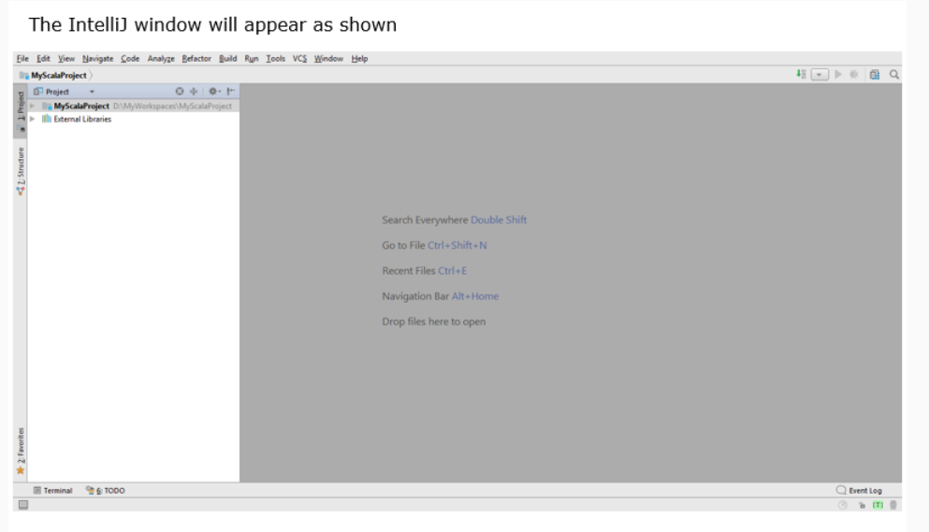

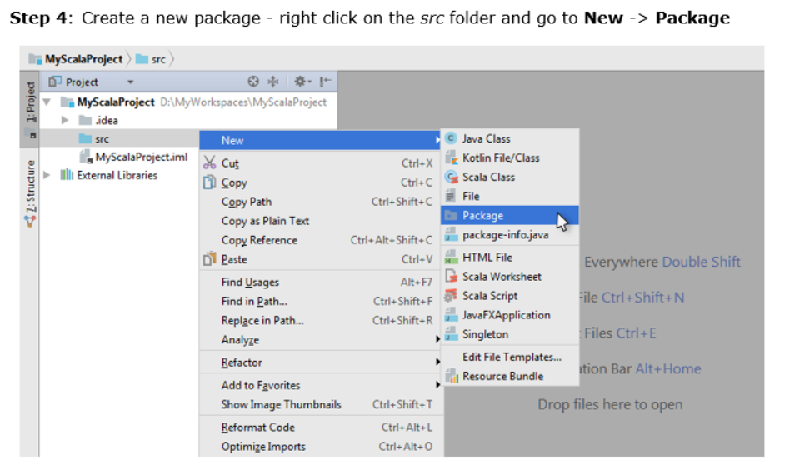

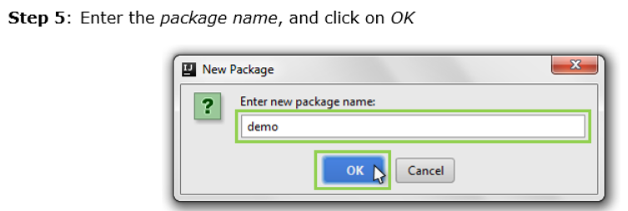

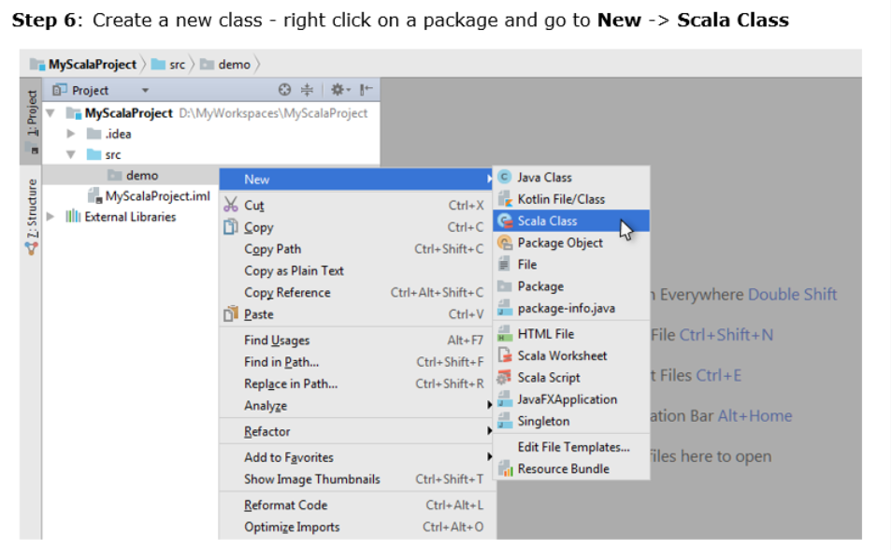

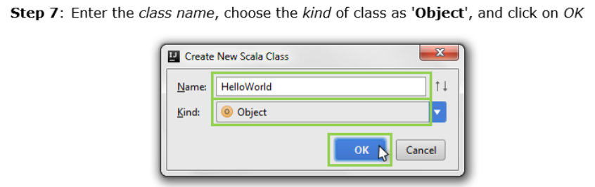

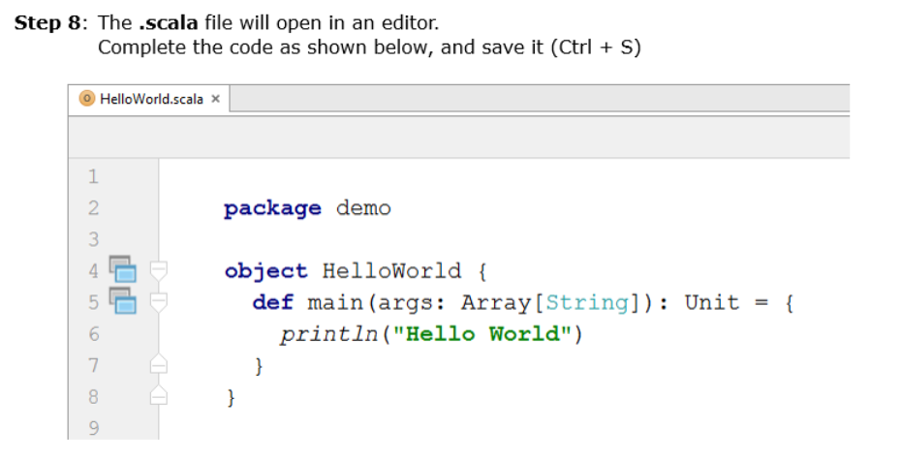

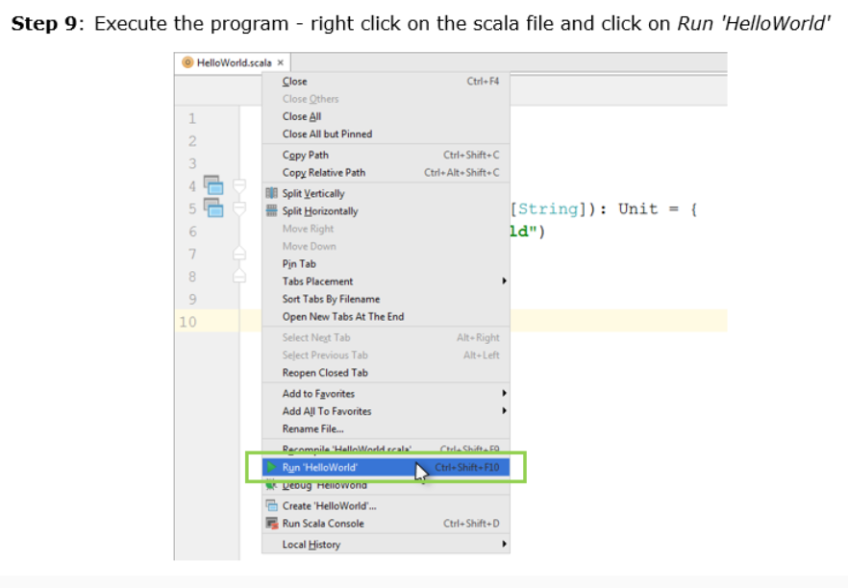

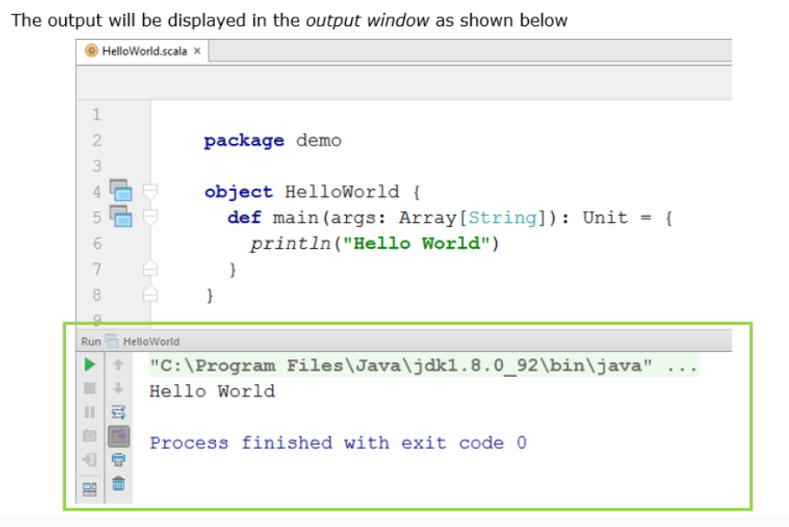

The First Program (with SBT)

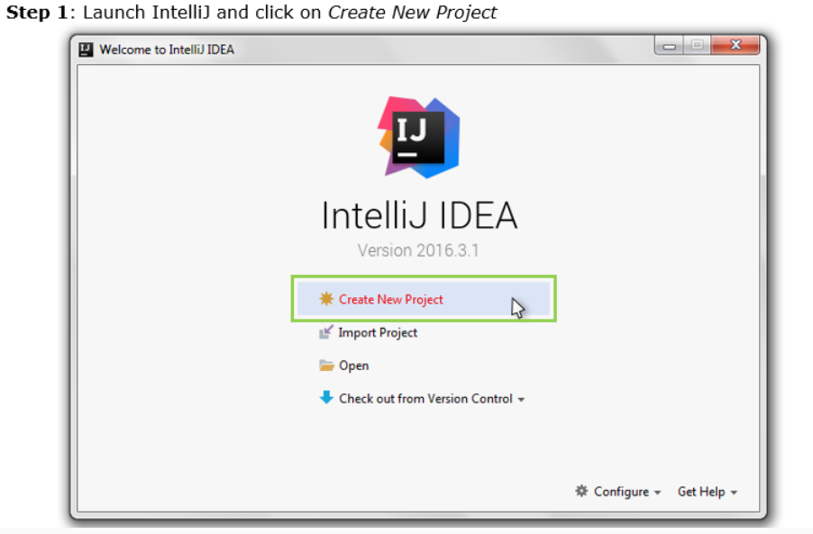

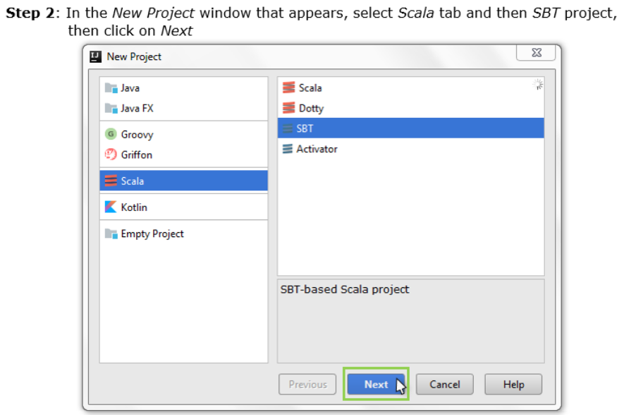

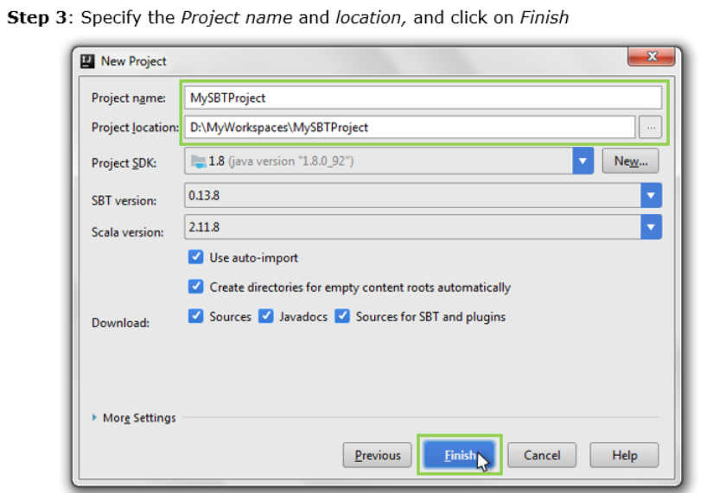

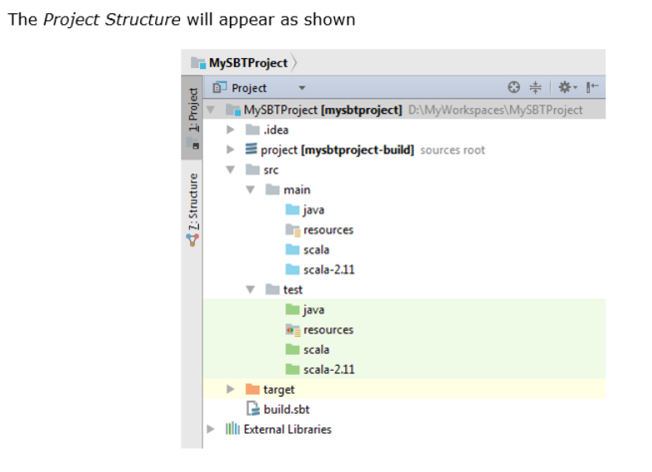

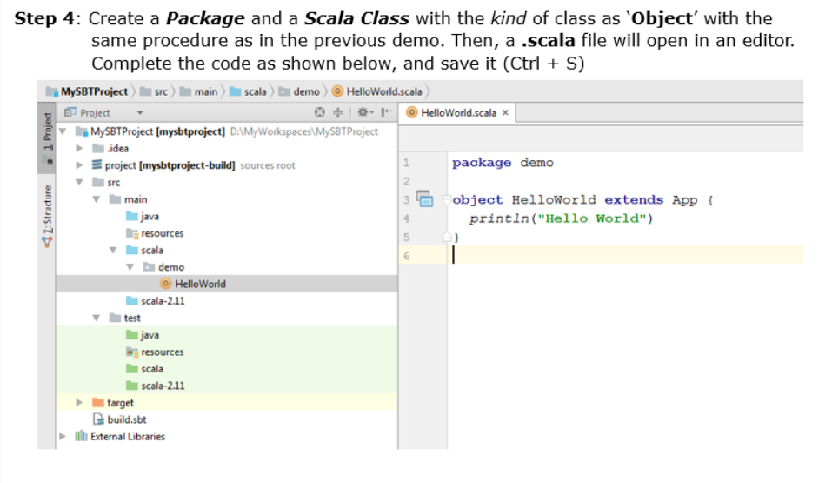

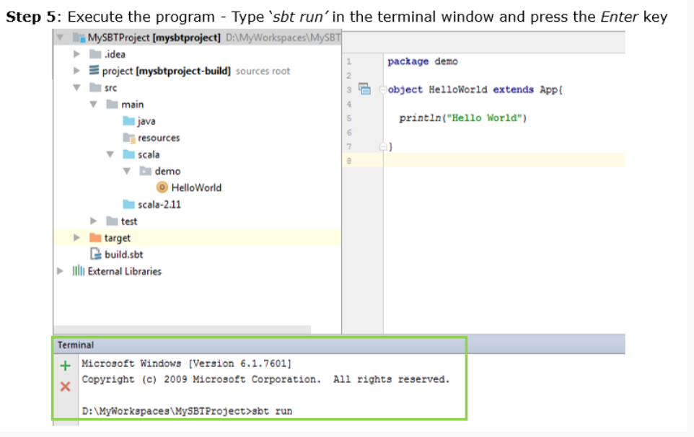

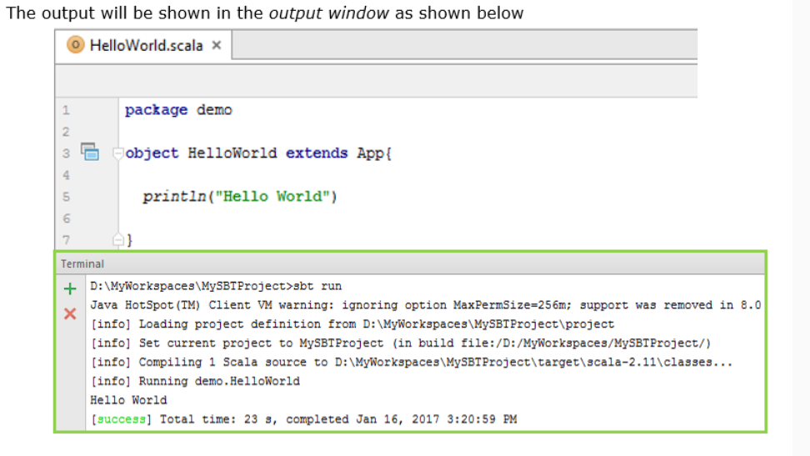

To Do the Spark Programming in Intellij

Steps :

1. Create build.sbt under the target table in the project 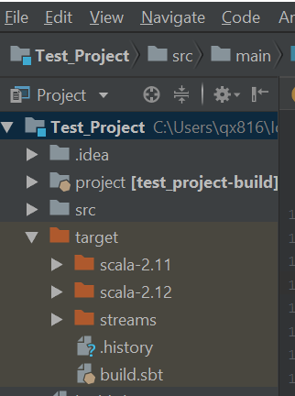
2. Enter the below of the any one code inside

name := "SparkTwoExperiments" // Project name

version := "1.0"

scalaVersion := "2.11.8" // scala version using for the project

val sparkVersion = "2.3.0"

resolvers ++= Seq(

"apache-snapshots" at "http://repository.apache.org/snapshots/"

)

libraryDependencies ++= Seq(

"org.apache.spark" %% "spark-core" % sparkVersion,

"org.apache.spark" %% "spark-sql" % sparkVersion,

"org.apache.spark" %% "spark-mllib" % sparkVersion,

"org.apache.spark" %% "spark-streaming" % sparkVersion,

"org.apache.spark" %% "spark-hive" % sparkVersion,

"mysql" % "mysql-connector-java" % "5.1.6"

)

======= or

name := "Test_Project"

version := "1.0"

scalaVersion := "2.11.12"

// https://mvnrepository.com/artifact/org.apache.spark/spark-core

libraryDependencies ++= Seq("org.apache.spark" %% "spark-sql" % "2.2.0", "org.apache.spark" %% "spark-mllib" % "2.2.0",

"org.apache.spark" %% "spark-streaming" % "2.2.0",

"org.apache.spark" %% "spark-core" % "2.2.0"

)